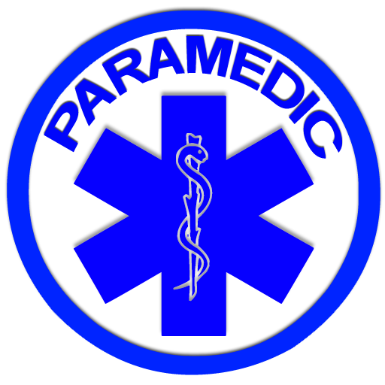

Fisdap Testing Dates for Spring 2017 EMST (Paramedic Program) Application:

Monday, October 10, 2016 at 6:00PM
Friday, October 14, 2016 at 9:00AM
Tuesday, October 18, 2016 at 4:00PM

For more information, contact Christie Linger-Hunt in the Testing Center at (304) 205-6670 or by email at Christie.Linger-Hunt@BridgeValley.edu

