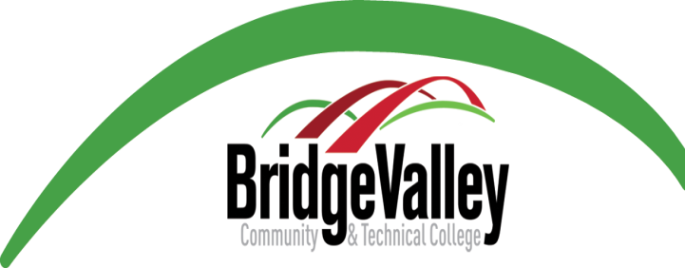

National Council Licensure Examination (NCLEX)
First-Time Passage Success Rate

 | National | West Virginia | BridgeValley
January 1, 2013- December 31, 2013 | 83.04% | 81.64% | 82.09%
January 1, 2014- December 31, 2014 | 81.79% | 83.51% | 82.28%
January 1, 2015- December 31, 2015 | 84.51% | 86.73% | 89.19%
January 1, 2013- December 31, 2015 (3-Year Mean) | 83.12% | 83.93% | 82.86%

