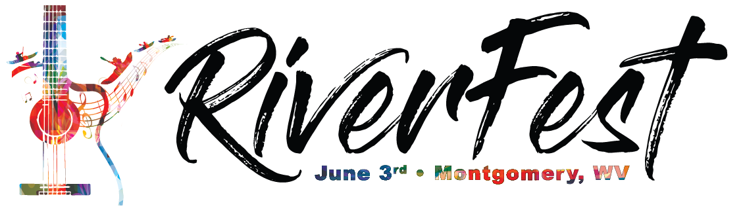
VENDOR REGISTRATION FORM

____Food ____ Artist ____ Outfitter ____ Other

WHERE: RiverFest, City of Montgomery, Adams Street and Sixth Avenue, Montgomery WV 25136

WHEN: Saturday, June 3, 2017 Noon until 10:00 p.m.

SET-UP: Day of event – Saturday, June 3, 2017, from 10:00 a.m. to noon. All additional vehicles MUST be moved out of the festival area by 11:30 a.m. on the day of the festival. Necessary inspections will begin prior to opening.

DEADLINE: All applications must be submitted by May 20, 2017.

VENDOR SPACE: Booth space is limited to a single 12’x12’ booth (including all wires, stakes, poles, etc.) with a good roof that can withstand wind, rain and other inclement weather. Come prepared for all types of weather. You must secure your booth in case of windy conditions. All items being sold or displayed must be contained in booth space.

HOLD HARMLESS AGREEMENT: This agreement is made upon the express condition that the City of Montgomery, its agents and employees shall be free from all liabilities and claims for damages and/or suits for or by reason of any injury, or death to any person or property of the Vendor, its agents or employees, or third parties, from any cause or causes whatsoever while in or upon said premises or any part thereof during the term of this agreement or occasioned by any occupancy or use of said premises or any activity carried on by the Vendor in connection herewith, and the Vendor hereby covenants and agrees to indemnify, defend, save and hold harmless the City of Montgomery, its agents and employees from all liabilities, charges, expenses and costs on account of or by reason of any such injuries, deaths, liabilities, claims, suits or losses however occurring or damages growing out of the same.

REQUIREMENTS: The Vendor will be responsible to be open during the entire festival. You cannot vacate early. Your booth must be neat, attractive and well-maintained. Signage with visible and clear pricing is required. You are responsible for setting up, maintaining and removing your own booth, merchandise and trash.

CONTACT: Jennifer Bunner – Festival Coordinator
City of Montgomery
706 Third Avenue
Montgomery WV 25136
Phone: 304-719-0579
Fax: 304-442-5395
Email: JenniferLBunner@gmail.com

APPLICATION CHECKLIST: Please mail, fax or e-mail the following items for approval: Application
Payment
Food menu with pricing (if applicable)
Affirmation & Liability Release
Photo of your booth / any high-quality photos for our website and advertising

KEEP THIS COVER SHEET FOR YOUR INFORMATION
Business Name: _______________________________________________________________

Contact Name:_________________________________________________________________

Phone: _________ - _________ - _______________

Street or PO Box: _______________________________________________________________

City: _________________________________________________ ST:_____ Zip: ____________

E-mail Address (required): ________________________________________________________

Nature of goods to be sold:_______________________________________________________

Do you have (please circle): Facebook, Twitter, Instagram Hashtag:_______________________

The deadline is May 20, 2017. Vendor hereby requests permission to display and sell the products and/or services listed above. Further, the Board of Parks and Recreation of the City of Montgomery, reserves the right to approve any product/item a vendor may wish to sell or dispense as well as limit the number of concessions selling the same product/item. DO NOT bring items to the festival unless previously approved. On the day of the festival, our standards committee will be monitoring compliance. I have read and understand and will abide with the RiverFest general information, procedures, rates and conditions. By signing this application, I acknowledge that the festival is subject to various weather conditions and state and federal safety and health regulations. No refund of application fees. Exhibits must remain open until closing.

Applicant Signature:_______________________________________ Date: ____________

Please Print Name: ________________________________________________________
The above named has read and understands the general information, procedures and conditions and seeks admission as a vendor. The City of Montgomery reserves the right to refuse any application. Submission of this application does not guarantee a space.

RAFT(River Arts Festival & Triathlon) Vendor Fees
_______ 12’x12’ Food/Business Vendor Space $50
_______ 12’x12’ Art Vendor Space $25
No Fee for non-profits distributing program materials for free.

PAY BY CHECK Please make all checks payable to:
RiverFest
City of Montgomery
706 Third Avenue
Montgomery WV 25136.

AFFIRMATION & LIABILITY RELEASE
I, ____________________________________, hereby affirm that I have been well advised and thoroughly informed of the inherent hazards and policies of the event. I know that by participating RiverFest, I am exposing myself to certain known and unknown liabilities in my direct and indirect actions with the public and invitees of this event. I also understand that if I choose to hire help for the event, that I am directly responsible for their actions or injury. I hereby personally assume all risks associated with my participation in this event for any harm, injury or damage that may befall me or any employee held liable in any way for any occurrence in connection with my participation in RiverFest that may result in injury, death, or other damages to me or my family, heirs, or assigns, and in consideration of being allowed to participate in this event, I hereby personally assume all risks in connection with said event for any harm, injury, or damage that may befall me, including all risks connected therewith, whether foreseen or unforeseen; and further to save and hold harmless said event and persons from any claim by me, or my family, estate, heirs, or assigns arising out of my participation in this event. I further state that I am of lawful age and legally competent to sign this affirmation and release, or that I have acquired the written consent of my parents or guardians; that I understand the terms herein are contractual and not a mere recital; and that I have signed this document of my own free will. It is my intention by this instrument affirmed by my signature below to exempt and release the City of Montgomery, their members, directors and officers from all liability whatsoever for personal injury, employer’s liability and workers’ compensation, property damage or wrongful death arising out of or in the course of my participation in this event. I HAVE FULLY INFORMED MYSELF OF THE CONTENTS OF THIS AFFIRMATION AND RELEASE BY READING IT BEFORE I SIGN IT.

Company Name_______________________________________________________________

Signature of Participant _________________________________________________________

Date ________________________________________________________________________

Print Name ___________________________________________________________________

