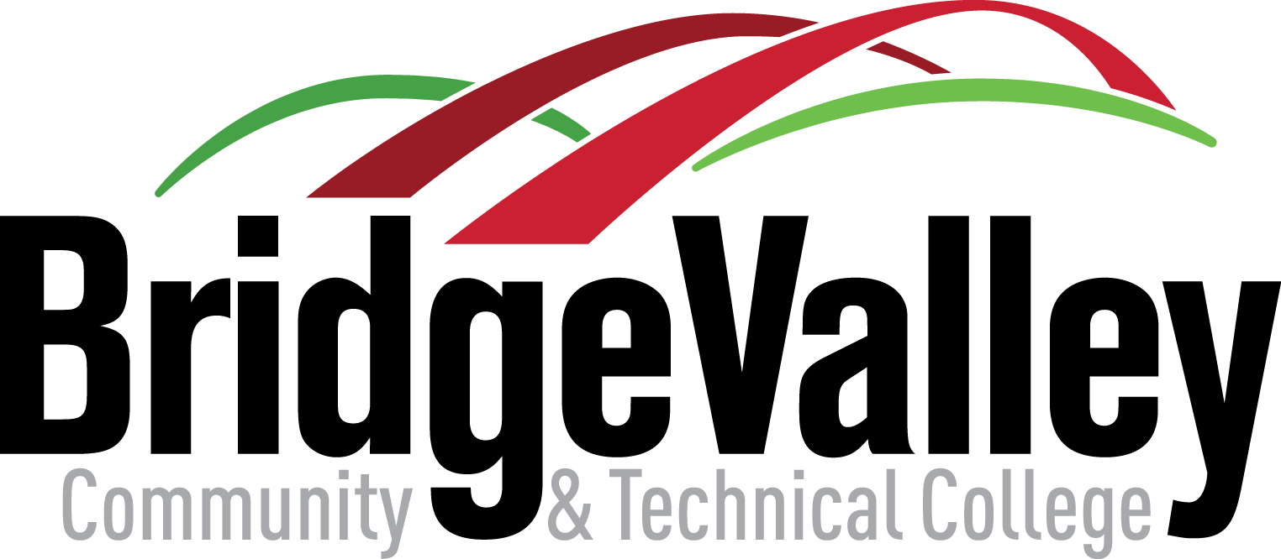

As members of the BridgeValley community, we believe in the inherent value of striving for excellence, in a sense of honor and service that springs from mutual respect and extends to the way we conduct ourselves at college and beyond. We recognize that every person's best effort is vital to success so we commit to uphold an environment conducive to learning characterized by academic integrity.

