Want to Partner?

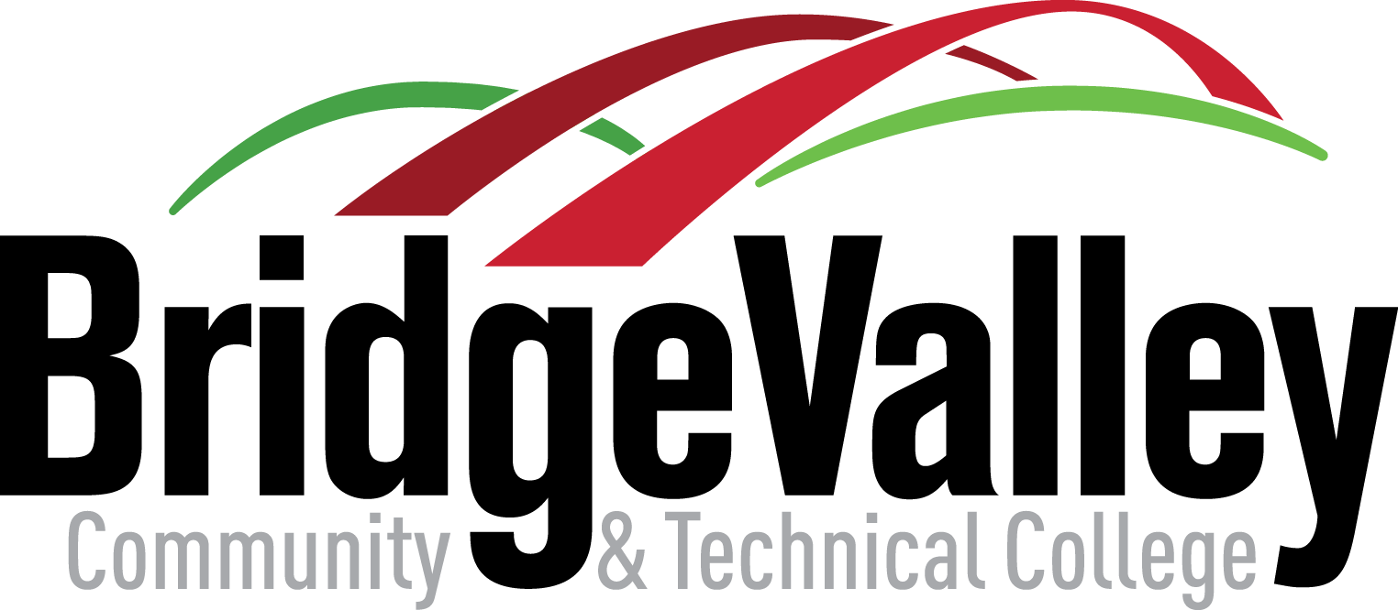

Name and Email Address: Jessica Wagner Jessica.Wganer@bridgevalley.edu

Institution: BridgeValley Community and Technical College

Discipline: Hospitality
Course/Courses you seek to Partner: Customer Service -HOSP 110

Semester you hope to offer a COIL Course: Spring 2022

Likely Class Size: 3-5

Discipline or country with whom you may prefer to partner: Any

Motivation for COIL: For Hospitality students to learn that customer service is crucial in every aspect of their careers, and that even though it may look different for another county due to customs or traditions, it is still important.

